Gaussian Report

Part1:

-binclass.txt

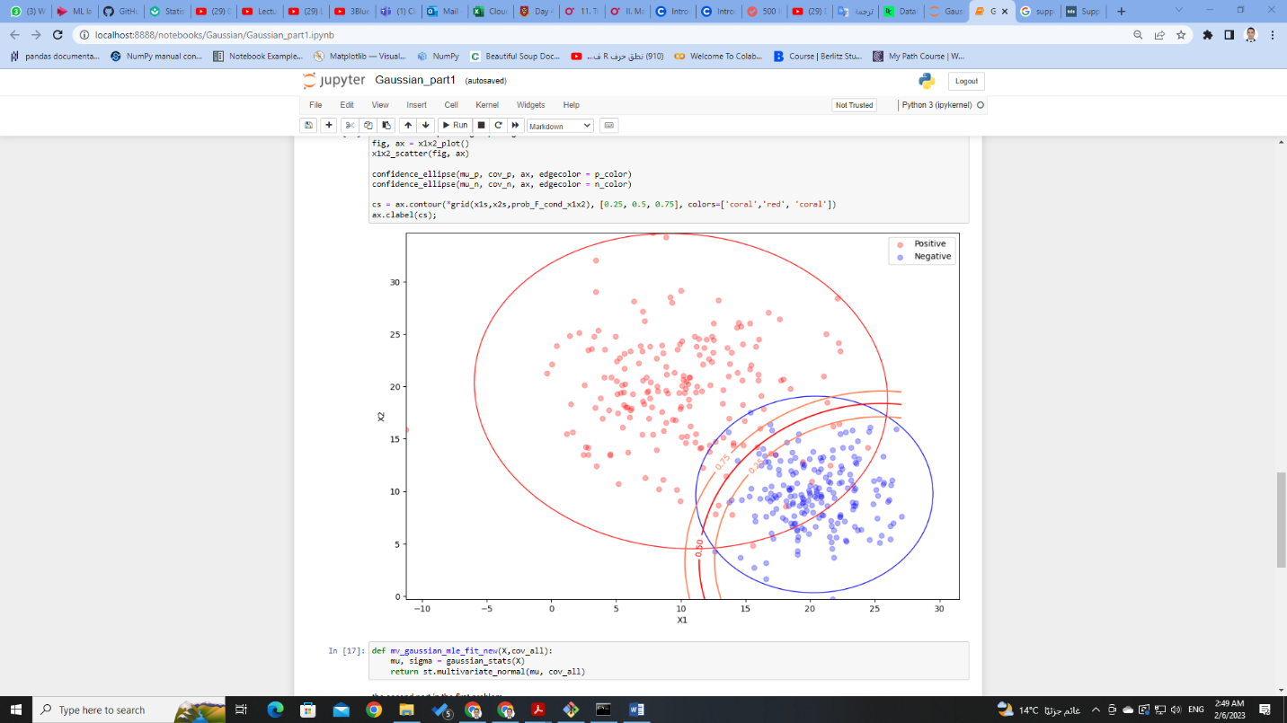

Part2:

-binclass2.txt

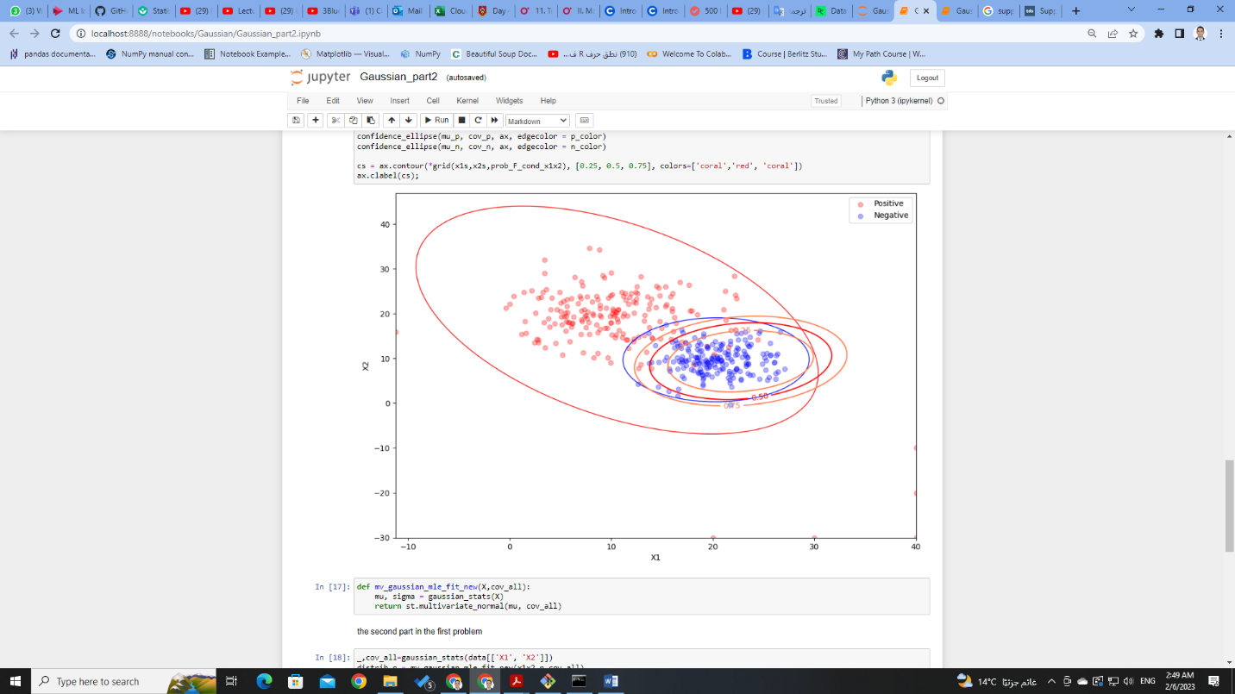

Observation:

-It seems that the models classify the data well from both

datasets, where the first model classifies the data that are a little overlapped and the second one classifies the data well too, where the data are involved with each other.